According to Java if we want to develop server side or backend technologies
JEE – Java Enterprise Edition
JEE or JavaEE or J2EE
Servlet, JSP (Java Server Pages) and EJB (Enterprise Java Bean).
Using Servlet, JSP and EJB we can create server side programming language.
To run these server side programming language we need server. Because Servlet, JSP and EJB doesn’t contains main method. in Servlet side technologies compile the program, create the war and deploy on server.
Application point of view. Server mainly divided into 2 types
- Web Server : Tomcat : it is a type of open source web server provided by Apache.
- Application Server : Web Logic, JBoss, Glashfish etc.

Server contains engine or run time environment to run the servlet, jsp as well as EJB program. That engine also known as container. Container is a part of servlet take care the life of servlet, jsp and ejb in java.
These container mainly divided into 2 types.
Web container : if server is a type of web server (tomcat) which contains only one type of container ie web container. This container is responsible to execute servlet and jsp program.
EJB container : if server is a type application server which can contains different type of container ie web container, ejb container , jms container et.
Web container run servlet and jsp application
In development mode we use web server like tomcat
In production mode we use application server.

Ejb container run ejb application

Spring framework and spring boot

Download tomcat 9.x version from below URL
https://tomcat.apache.org/download-90.cgi
download zip folder.

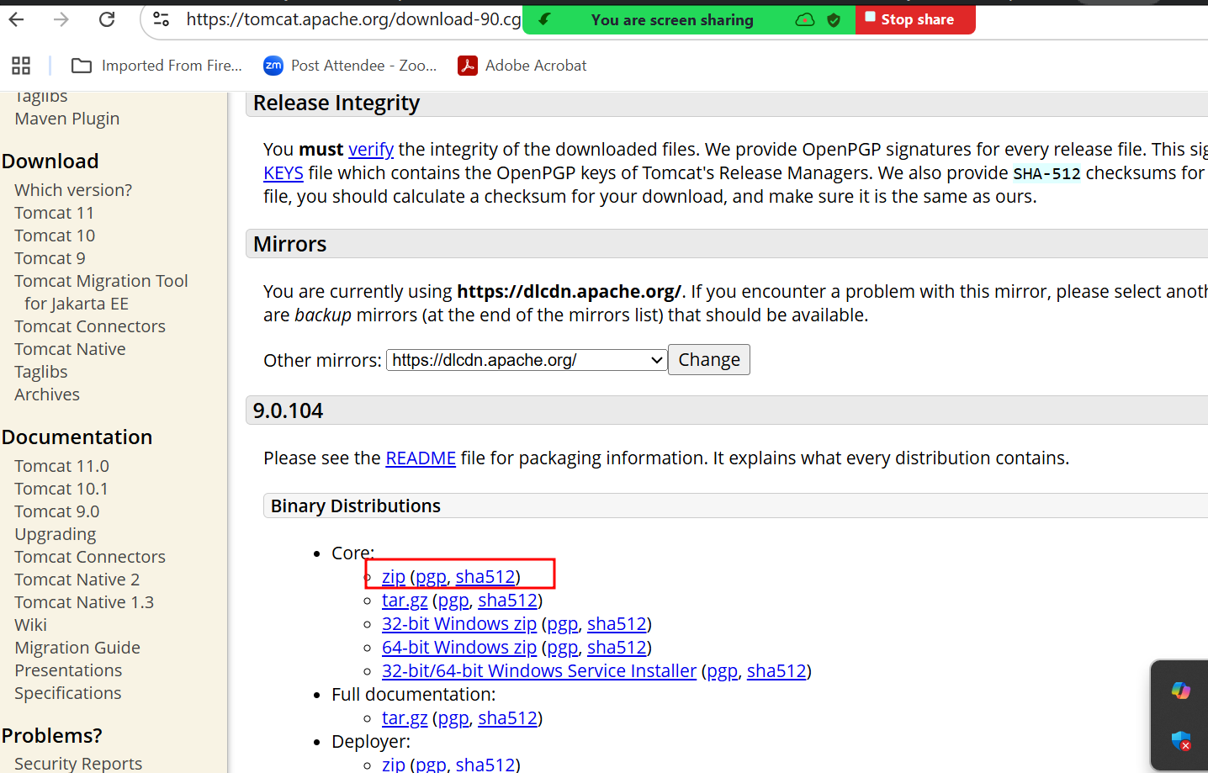

Servlet : Servlet is normal java program which help to create dynamic web page on server side.
To create servlet program
We need to use javax.servlet.*; servlet is a package. which contains set of classes and interfaces.
Servlet : Servlet is an interface. This interface contains set of method ie abstract methods. 5 methods.
init initialization only once at initially called.
service this method call again and again whenever client send the request. which take 2 parameter request and response.
destroy this method call at last to destroy the objects.
init, service and destroy are life cycle methods.
getServletInfo
getServletConfig

1st approach
public class MyServlet implements Servlet {
we need to override all 5 methods mandatory.
}
GenericServlet : it is a type of abstract class which internally implements Servlet interface and provided body for 4 methods except service methods.
2nd approach
public MyServlet extends GenericServlet {
we need to override only service method.
}
HttpServlet : it is a type of abstract class which internally extends GenericServlet and provided body for service methods. This class provide few extra method in the form of doXXX like doGet, doPost, doPut, doDelete etc.
3rd approach
Public MyServlet extends HttpServelt {
doGet or doPost
}

